**Duquesne Incline Preservation Society Design Guide**

# Logo

# Colors

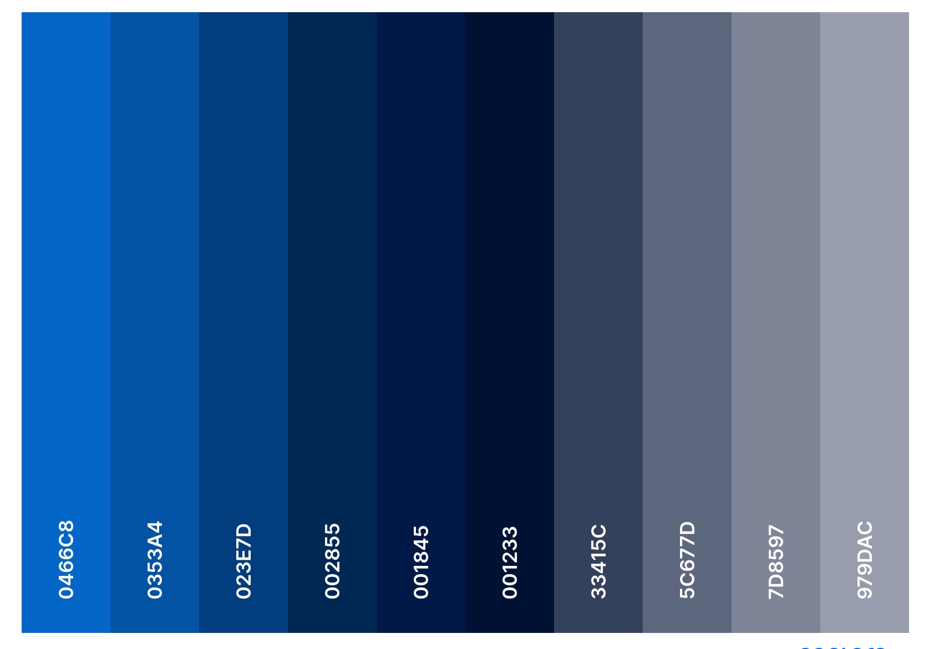

FFFFFF

# Fonts (sans-serif)

Helvetica Neue Helvetica

Arial

Sans-serif

# Title

# Subtitle

Heading 1

Heading 2

Heading 3

Body